[Tutorial] C Structure Exercise
Student ID: 22100510
Student Name: Lee Seonyu

Exercise 1

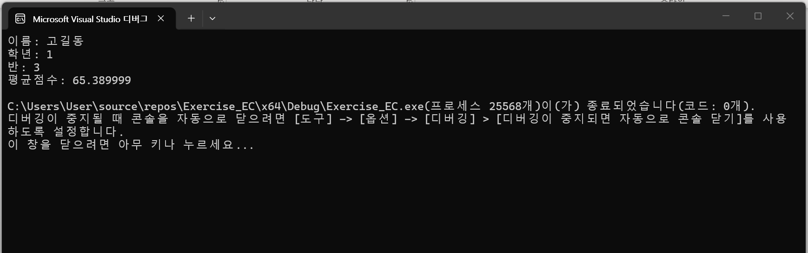

Exercise 2

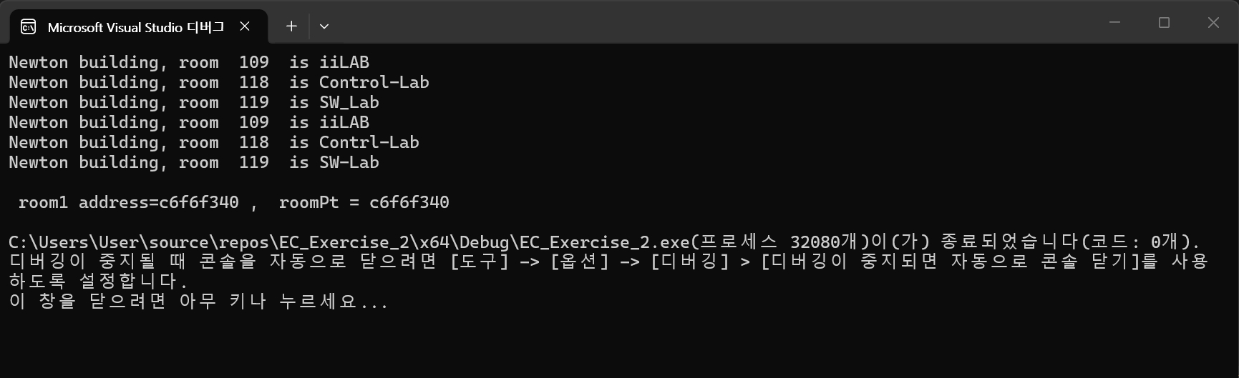

Exercise 3

